# 

# BAN 630

# OPTIMIZATION FOR ANALYTICS

**In-n-Out Burgers Order-line Optimization**

**Submitted By:**

Manisha Boyina

Sarthak Meliwal

Swanand Jamadagni

Contents

BAN 630 1

OPTIMIZATION FOR ANALYTICS 1

INTRODUCTION 2

BUSINESS PROBLEM 3

APPROACH 3

STEP 1: Examine an existing system and quantify its operating characteristics: 4

STEP 2: Optimization 6

STEP 3: What-If Analysis 8

Conclusion 9

## INTRODUCTION

As California residents we all have been to In-n-Out Burgers or at-least heard about it. In-N-Out Burger is a well-known fast-food chain that originated in California in 1948 and has since expanded to several states in the western United States. Known for its delicious burgers, fresh ingredients, and friendly service, In-N-Out has garnered a dedicated fan base. Despite its popularity, the chain has deliberately kept its expansion relatively limited, maintaining its focus on quality and customer satisfaction. In-N-Out locations can be found in California, Nevada, Arizona, Utah, Oregon, and Texas, with new restaurants occasionally opening in neighboring areas. The limited geographic presence has only heightened the brand's appeal and created a sense of exclusivity. In-N-Out's simple menu, featuring burgers, fries, shakes, and a few other items, has become iconic, and the chain's "secret menu" has added to its allure. With its commitment to providing fresh, made-to-order meals and a strong regional identity, In-N-Out continues to be a beloved fast-food establishment for burger enthusiasts across the western United States.

However, surveys state that the immense popularity of In-N-Out has also led to a bottleneck situation where customers often encounter significant delays when placing their orders. As a consequence, customers have started associating In-N-Out with prolonged waiting times and the presence of extensive queues.

## BUSINESS PROBLEM

Our team (Manisha Boyina, Sarthak Meliwal, Swanand Jamadagni) was assigned the responsibility of addressing the prevalent issue of the excessively lengthy queues and extended waiting periods that have become synonymous with the dining experience at In-N-Out Burger at an outlet located in the campus grounds of UCLA.

Our primary emphasis in this situation revolved around identifying the ideal number of servers to be employed to tackle the high arrival and service rates prevalent in this In-N-Out store.

## APPROACH

We intend to develop a queuing model to identify the ideal number of servers to handle the current arrival and service rates in the outlet at the same time ensuring minimal total cost of services and customers waiting.

Queueing optimization models are mathematical tools used to optimize the performance of waiting lines or queues in various systems. These models aim to minimize customer waiting times, reduce congestion, and improve resource utilization. By analyzing factors such as arrival rates, service times, and queue capacities, queueing optimization models help in understanding system behavior, identifying potential bottlenecks, and developing strategies to optimize the overall queueing process.

Queueing optimization models have widespread applications across industries such as transportation, healthcare, telecommunications, and manufacturing. In transportation, these models can be utilized to optimize traffic flow at intersections or design efficient queuing systems for public transportation. In healthcare settings, queueing optimization models can assist in optimizing patient flow in hospitals, reducing waiting times for treatments or surgeries.

These models typically consider various factors such as queue discipline, service time distributions, arrival patterns, and system capacity to formulate mathematical equations and simulation models. By analyzing these models, decision-makers can gain insights into system performance, make informed decisions about resource allocation, staffing levels, and service improvements. Ultimately, the goal of queueing optimization models is to enhance customer satisfaction, improve operational efficiency, and optimize the utilization of resources in queueing systems.

## STEP 1: Examine an existing system and quantify its operating characteristics:

The operating characteristics and assumptions for this queuing model have been developed based on the research carried out by Andrew Von Hasligen for his case study[**IN-N-OUT BURGER - UX+UI**](http://avhaslingen.com/innout). The research for his case study was carried out by means of conducting interviews and sending out surveys to potential interviewees who often ate at the said In-N-Out store and ordered inside the restaurant.

The case study further profiles a customer who often eats at the said In-Out-Store as a student of UCLA, in her 20s.

On the basis of the case study, the following assumptions have been made:

* Provided that the store is located on UCLA campus grounds, the customers are mostly students.
* So their per hour wages for on campus jobs is $17.
* All the equipment and infrastructure cost is ignored from the model since we don't have enough data for estimating those values.
* Arrival rate is assumed to be following possession distribution.
* Service rate distribution is assumed to be negative exponential.
* Queue discipline is assumed to be FCFS
* Calling population is assumed to be infinite
* Size of queue is assumed to be infinite.

On the basis of the case study, the following parameter values have been determined:

* Unit of Time - Hour
* Arrival Rate - 73.48 Customers/Hr (derived from queue length and service rate)
* Service Rate - 80 Customers/Hr
* Service Cost - $15 per hour
* Waiting Cost - $17 per customer / hour
* Length of the queue - 10 customers / Hr (given in case study)
* No of servers - We will analyze the total cost for range of servers from 1 to 10.

Derivation for Arrival Rate:

Lq = 𝞺*𝝺 / 𝛍 - 𝝺

𝞺 = 𝝺 / 𝛍

Lq = ((𝝺 / 𝛍)*𝝺) / 𝛍 - 𝝺

10 = ((𝝺 / 80)*𝝺) / 80 - 𝝺

𝝺^2 + 800𝝺 - 64000 = 0

after calculating roots for above polynomial we get:

𝝺1 = −400+10 * 2240 ≈ −400+10⋅47.348 = 73.48

𝝺2 = −400−10 * 2240 ≈ −400−10⋅47.348 = -873.48

since the arrival rate can not be negative we are considering the 𝝺 = 73.48

Derivation for service & waiting costs:

Based on the average per hour salary for an In-n-Out cashier we are considering the service cost is $15.

Reference - [Per hour salary for In-n-Out cashier](https://www.glassdoor.com/Hourly-Pay/In-N-Out-Burger-Hourly-Pay-E14276.htm)

Since we are considering most of the customers are UCLA students we are assuming that customer waiting cost is equal to their average per hour wages for on campus jobs. So, the waiting cost is $17

Reference - [UCLA on campus average hourly wages](https://www.glassdoor.com/Hourly-Pay/UCLA-Work-Study-Student-Hourly-Pay-E32524_D_KO5,23.htm)

## STEP 2: Optimization

Different queuing models have been built assuming either s = 1 or s >1.

* The M/M/1/FCFS/∞/∞ model is as below:

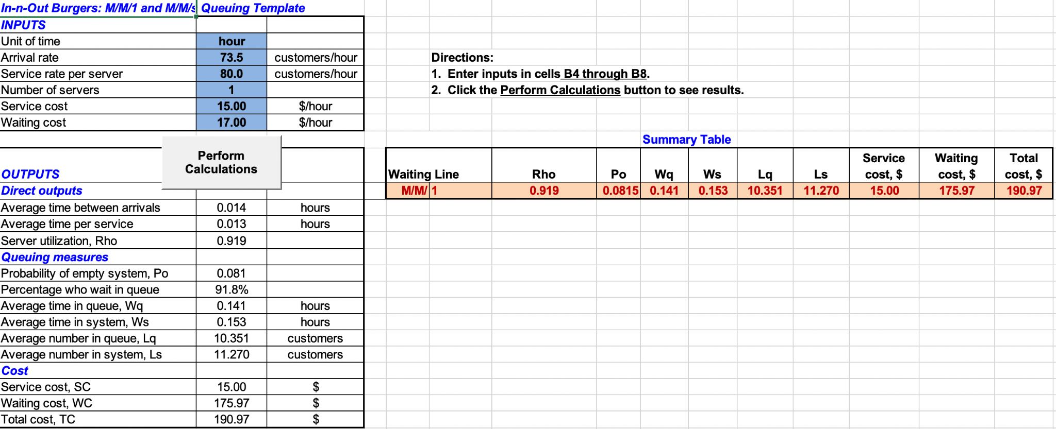

* The M/M/s/FCFS/∞/∞ model is as below:

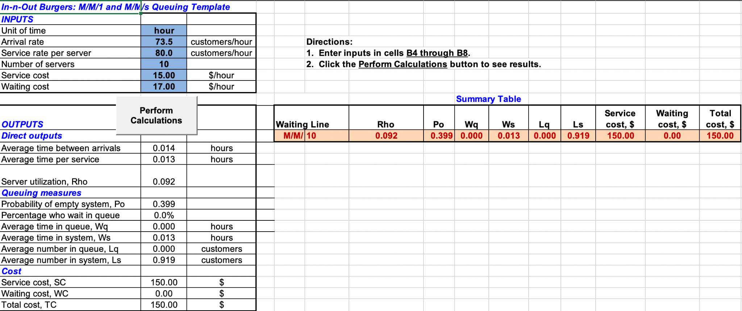

The waiting times (Wq) and its associated total costs for different numbers of servers have been listed below:

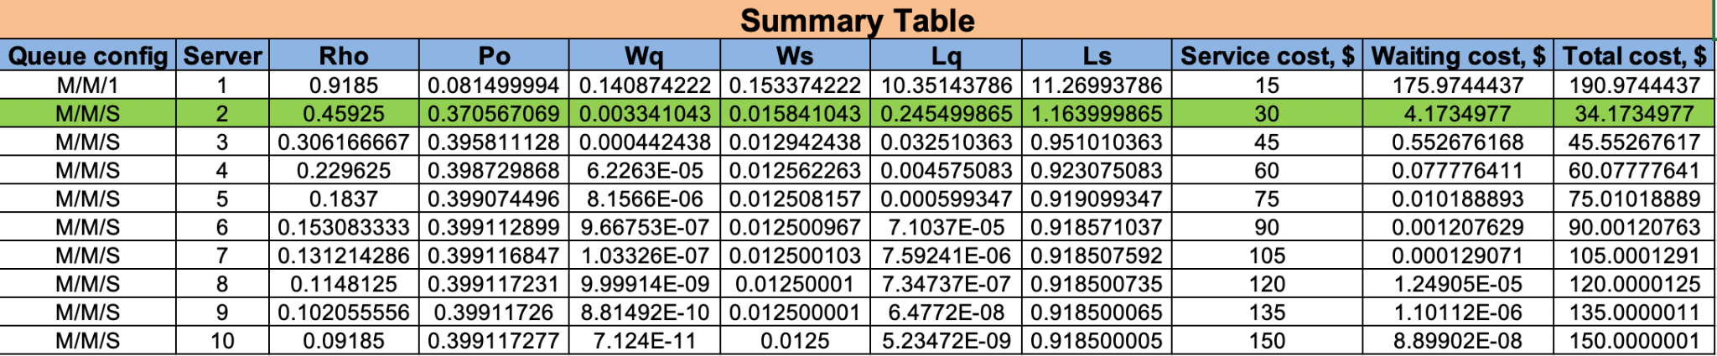

Cost Analysis:

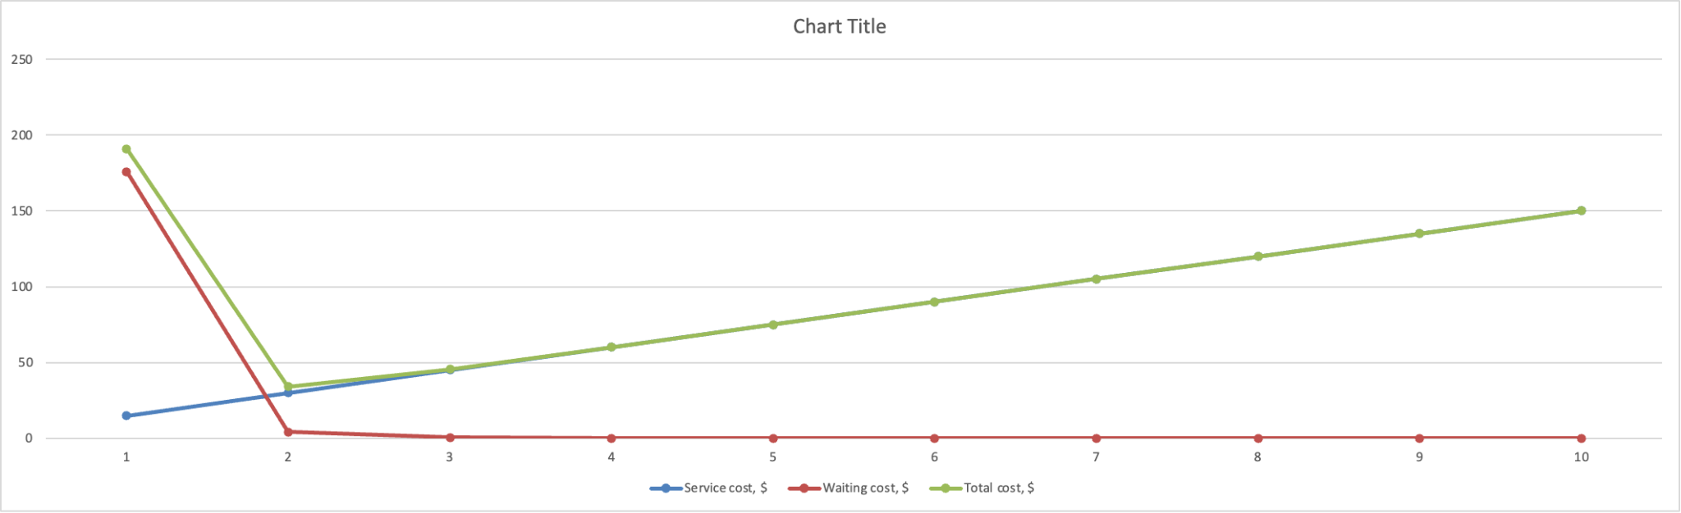

Recommendation based on queuing model output:

From the above summary table and cost analysis graphs we can see that the lowest total cost is with the total number of servers being 2.

And the waiting time is also very less with the total number of servers being 2.

Thus we recommend the branch / store to employ 2 servers so that they tackle the increasing arrival rate & service rate with least total cost possible.

## STEP 3: What-If Analysis

Since we are assuming service and waiting costs based on just one internet reference we would like to check the impact of their changes on the optimal solution.

Hence we are running a what-if analysis on a range of service and waiting cost with Inflation rate as 4%, 6%, 8%

Inflation rate 4%

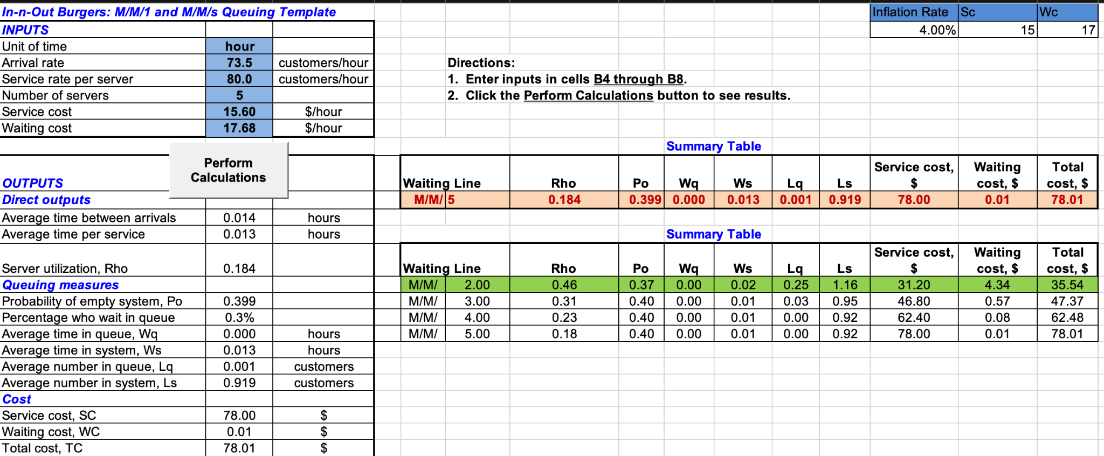

Inflation rate 6%

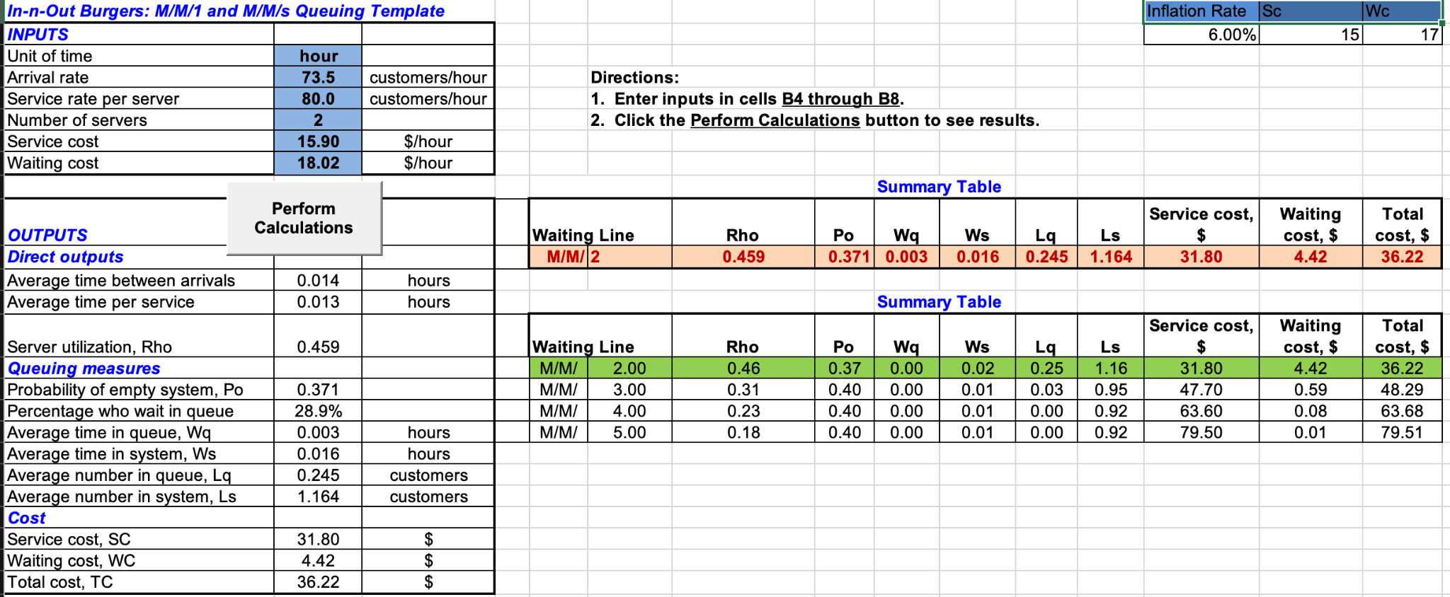

Inflation rate 8%

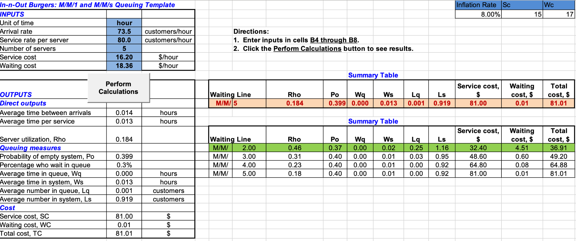

## CONCLUSION

As we can see from what-if analysis even with considering realistic inflation the optimal number of servers for least total cost and short waiting time is still 2.

## REFERENCES

* <http://avhaslingen.com/innout>
* <https://www.glassdoor.com/Hourly-Pay/In-N-Out-Burger-Hourly-Pay-E14276.htm>
* <https://www.glassdoor.com/Hourly-Pay/UCLA-Work-Study-Student-Hourly-Pay-E32524_D_KO5,23.htm>